Experiment No. 4
Software Engineering Lab – Activity Diagram
ContextGuard — Repository-Context-Aware Verification Filtering for Reliable LLM-Based Code Review
Group: SE_B054_B062_B131

Aim
To create the Activity Diagram for ContextGuard by identifying the system's activities and the actors performing them, and to represent the sequential, branched, and parallel flow of the PR-verification workflow.

Prerequisite
- Basic understanding of the functionality of the ContextGuard system, established through Experiments 1–3 (requirements, use cases, and interaction analysis).

Learning Outcome
- Understand the various activities performed in the ContextGuard PR-verification workflow.
- Identify the actors and systems that perform each activity.
- Model sequential, branched (decision), and parallel (fork/join) flow using an activity diagram.

Part A – Theory

1. What is an Activity Diagram?
An activity diagram is a UML behavioural diagram that models the dynamic aspects of a system as a flow chart of activities. It shows the flow from one activity to another, and this flow may be sequential, branched, or concurrent, using elements such as decision nodes, fork, and join.

2. Finding the Set of Activities
- Analyse the system's functional requirements to identify each distinct operation it performs.
- List the activities in the order they are expected to occur.
- Identify the actor or subsystem responsible for each activity (its swimlane).
- Identify points where the flow branches (decisions) or splits into parallel work (fork/join).

3. Elements Used
Relation / Element | Usage in ContextGuard
Control Flow | Connects activities in the order in which they are performed
Decision | Checks conditions such as Valid/Invalid PR, Compliant/Non-Compliant verdict, and verification outcome
Fork | Splits verification into original-code and proposed-fix execution
Join | Synchronizes the two parallel execution paths
Merge | Combines alternative paths (e.g. Correct Flag / Confirm Non-Compliant) back into one flow
Swimlane / Partition | Groups activities by the actor or system responsible (Developer, GitHub, ContextGuard System, LLM Service, Test Environment, Reviewer)
Initial Node | Represents the beginning of the ContextGuard workflow
Activity / Flow Final | Represents termination of a path in the workflow
Guard Conditions | [Valid], [Invalid], [Compliant], [Non-Compliant], [Available], [Unavailable], [Identical], [Different], [Overrides], [Accepts]

Procedure
- Analyse the ContextGuard system (Experiments 1–3) to identify its activities.
- List the activities and the actors/systems who perform them.
- Identify decision points, guard conditions, and any parallel activities.
- Draw the activity diagram showing all activities, control flow, decisions, fork/join, and merge nodes, organised into swimlanes.
Output: An Activity Diagram for the ContextGuard PR-verification workflow.

Part B – Activity Diagram Analysis for ContextGuard
ContextGuard is a repository-context-aware verification layer for reliable LLM-based code review. It accepts a GitHub pull request, performs an initial AI review, retrieves relevant repository context through hybrid dense and sparse retrieval, synthesises verification tests, executes the original and proposed-fix code in parallel, and produces a final evidence-backed verdict that a reviewer can approve, reject, or override.

B.1 Swimlanes / Actors Identified
Swimlane (Actor / System) | Role in the Activity Diagram
Developer (PR Author) | Submits the PR link, receives errors/notifications, and views the final verdict
GitHub | Supplies the PR diff, description, and repository metadata
ContextGuard System | Validates the PR, runs the AI review, retrieves repository context, synthesises tests, compares outcomes, and records the final verdict
LLM Service | Generates the initial review verdict and posts a compliant verdict
Test / Code Execution Environment | Executes the original code and the proposed fix against the synthesised tests
Reviewer / Maintainer | Reviews the evidence-backed verdict, may override it, and approves/rejects the PR

B.2 Activity Flow Description
1. PR Submission and Validation
The workflow begins when the Developer submits the PR link. ContextGuard validates the PR link and repository connection. If Invalid, an error is shown to the developer and the process terminates; if Valid, the system requests the PR diff, description, and repository metadata from GitHub.
2. PR Data Retrieval and Initial AI Review
GitHub provides the PR diff and metadata, which ContextGuard stores as intake information and uses to start the AI review workflow. The LLM Service generates the initial review verdict. If Compliant, the verdict is posted to the PR; if Non-Compliant, the PR proceeds to ContextGuard verification.
3. Repository Context Retrieval
When flagged Non-Compliant, ContextGuard checks whether the verification service is Available. If Unavailable, it follows a fail-open path, posting an unverified labelled verdict and alerting the on-call engineer. If Available, it retrieves relevant repository context using hybrid dense and sparse retrieval.
4. Verification Test Synthesis
Using the retrieved context, ContextGuard synthesises verification tests that act as the test oracle for comparing the original code against the proposed fix.
5. Parallel Code Execution
A Fork node splits the flow so that the Test/Code Execution Environment runs the original code and the proposed fix against the synthesised tests independently and in parallel. A Join node then synchronises both paths before continuing.
6. Comparison of Execution Outcomes
ContextGuard compares the execution outcomes. If Identical, the original non-compliant flag is treated as a false alarm and corrected to compliant. If Different, the non-compliant flag is confirmed. Both branches are combined by a Merge node.
7. Final Verdict and Notification
ContextGuard records the final verdict together with the supporting evidence as an immutable log entry, then notifies both the Developer and the Reviewer. The developer can view the verified final verdict.
8. Reviewer Decision
The Reviewer/Maintainer reviews the evidence-backed verdict. If they accept it, the PR proceeds to Approve/Reject; if they override it, the override is recorded before the PR is approved or rejected, ending the workflow.

B.3 Activity Diagram
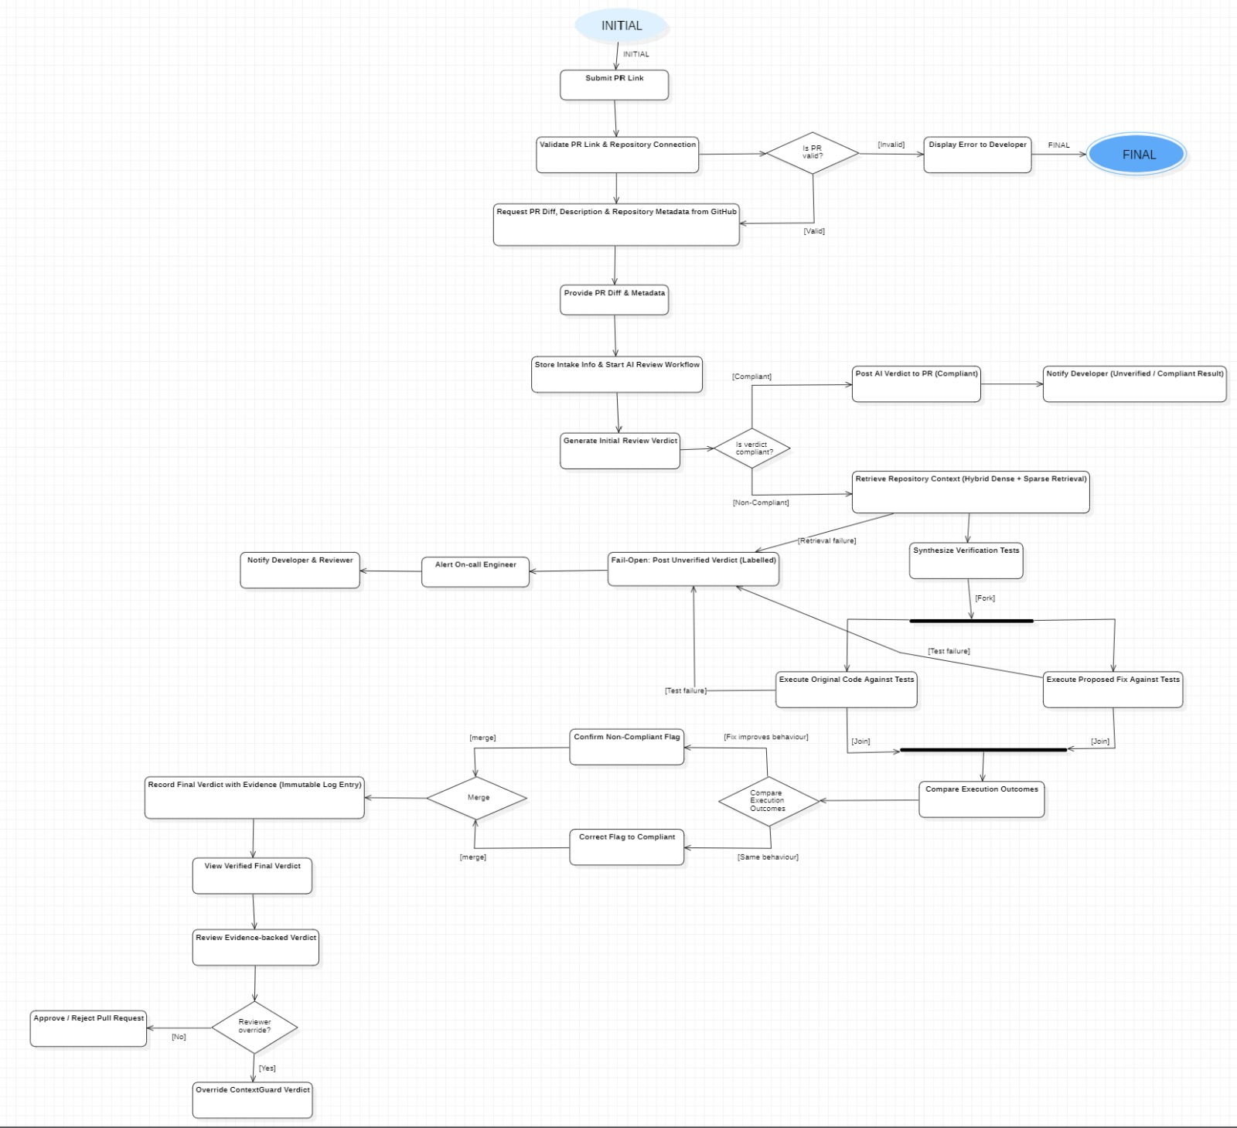

Fig. 1 – Activity Diagram of ContextGuard showing PR intake, AI review, repository-context retrieval, verification test synthesis, parallel execution, final verdict generation, and reviewer decision flow.

Output
An Activity Diagram for the ContextGuard PR-verification system, showing all activities, actors (swimlanes), decisions, guard conditions, fork/join, and merge nodes from PR submission to the final reviewer decision.

